medfilt2

2-D median filtering

[expand all in page](javascript:void(0);)

|  |
| --- |
| **Note:**   The syntax medfilt2(A,[M N],(Mb Nb],...) has been removed. |

**Syntax**

B = medfilt2(A, [m n])  
B = medfilt2(A)  
gpuarrayB = medfilt2(gpuarrayA,**___**)  
B = medfilt2(A,'indexed',**___**)  
B = medfilt2(..., padopt)

**Description**

B = medfilt2(A, [m n]) performs median filtering of the matrix A in two dimensions. Each output pixel contains the median value in the m-by-n neighborhood around the corresponding pixel in the input image. medfilt2 pads the image with 0s on the edges, so the median values for the points within [m n]/2 of the edges might appear distorted.

Median filtering is a nonlinear operation often used in image processing to reduce "salt and pepper" noise. A median filter is more effective than convolution when the goal is to simultaneously reduce noise and preserve edges.

B = medfilt2(A) performs median filtering of the matrix A using the default 3-by-3 neighborhood.

gpuarrayB = medfilt2(gpuarrayA,**___**) performs the filtering operation on a GPU. The input image and the output image are gpuArrays. When working with gpuArrays, medfilt2 only supports square neighborhoods with odd-length sides between 3 and 15. This syntax requires the Parallel Computing Toolbox™.

B = medfilt2(A,'indexed',**___**) performs median filtering of the indexed image A, padding with 0s if the class of A is uint8, or 1s if the class of A is double.

B = medfilt2(..., padopt) controls how the matrix boundaries are padded. padopt may be one of the text strings in the following table.

| **Value** | **Description** |
| --- | --- |
| 'zeros' | Padded with 0s. This is the default. |
| 'symmetric' | Symmetrically extended at the boundaries |
| 'indexed' | Padded with 1s, if the class of A is double; otherwise, padded with 0s |

**Class Support**

The input image A can be of class logical or numeric (unless the 'indexed' syntax is used, in which case A cannot be of classuint16). The output image B is of the same class as A.

The input gpuArray image gpuarrayA can be of class logical or numeric. The output gpuArray image gpuarrayB is of the same class as gpuarrayA.

|  |
| --- |
| **Note**   For information about performance considerations, see ordfilt2. |

**Examples**

Remove salt and pepper noise from an image.

I = imread('eight.tif');

J = imnoise(I,'salt & pepper',0.02);

K = medfilt2(J);

imshow(J), figure, imshow(K)

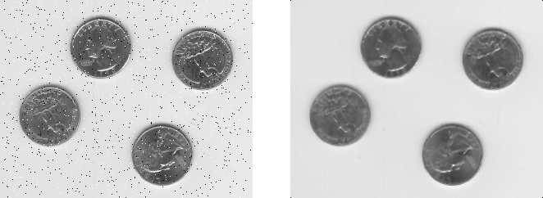

Remove salt and pepper noise from an image on a GPU.

I = gpuArray(imread('eight.tif'));

J = imnoise(I,'salt & pepper',0.02);

K = medfilt2(J);

figure, imshow(J), figure, imshow(K)